Following on from your Day with the Ancient Egyptians.

We really hope that you and your pupils had a great learning experience at Norwich Castle Museum and Art Gallery. Here are just a few ideas that you may like to use back at school following your visit.

Please feel free to amend and change any resources.

This pack includes:
- A list of possible follow-up activities linked to the national curriculum
- Resources for classroom use
  - Cairo Chronicle pupils’ sheet
  - Cairo Chronicle teachers’ sheet with prompts
  - Archaeologist’s letter pupil sheet
  - Instructions for mummification sheet
  - Teachers’ notes on mummifying a tomato!

Follow-up activities sheet

Activity | Brief notes | Curriculum area
Cairo Chronicle | Newspaper report about the tomb discovery. Writing could include work on paragraphing, alliteration and features of a newspaper report | History/Literacy/ICT
Archaeologist’s letter | The children write a letter to someone back at home in England as if they were the archaeologist, considering their feelings as well as giving information about the event | History/Literacy
Instructions for mummification | This can be a matching activity or it can be cut up and used for sequencing. The children could look at features of instructional text and highlight the imperative verbs | History/Literacy
Making jewellery/amulet | This could be finishing off the artefact they made at the museum or they could use self-drying clay to make amulets to place in the coffin with the mummy of Ankh Hor | History/DT
Prepare a feast for Ankh Hor’s family | Research food eaten in ancient Egypt and plan a menu, prepare the food and enjoy your feast.  The children could even make costumes, like the ones they used at the Castle, using pillow cases and decorating the edges | DT (Food Technology)
Become an embalmer! | The children can mummify a tomato. This includes lots of science and even a little maths | History/Science

The Cairo Chronicle

November 1865
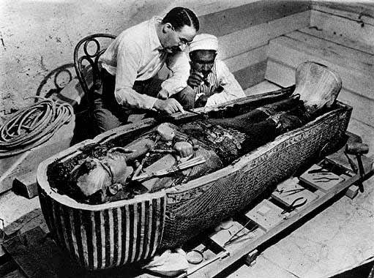
The Cairo Chronicle

November 1865
Put your headline here. It could be alliterative or a pun.
Paragraph 1- in very basic language tell the reader what happened, where, when, and who was involved.

Paragraph 2 and 3 - add more detail possibly including a quote from the archaeologist. Describe how the world is reacting to the find. Tell the reader what was found and by whom.

Final paragraph – write a summary and tell the reader that not everyone is convinced that the discovery is a good thing.

This space could be used for either an advert for a souvenir from the discovery or a trip to Egypt. Remember this is the 1860s. You could add an image from the internet if completing this activity using ICT.
Write a caption to describe the picture here.
A letter from the archaeologist

Can you imagine how the archaeologist felt when he saw the treasures for the first time? What would have caught his eye the most? What would have been happening all over the site?

Imagine that you are the archaeologist and write a letter home to one of your relatives telling them all about it.

Instructions for mummification

Can you match the instructions to the pictures?
Wash the body and then pull the brain out of the nose using a hook. | 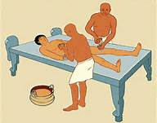
Make a cut on the left side of the body and remove the internal organs. Throw the brain away then place the lungs, intestines, stomach and liver inside canopic jars. Leave the heart inside the body. | 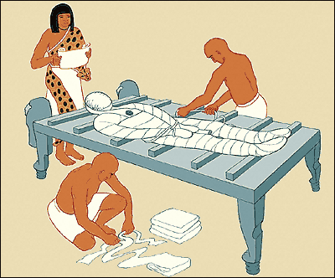
Stuff the body with linen soaked with incense to stop the body smelling and to give it a more human shape. | 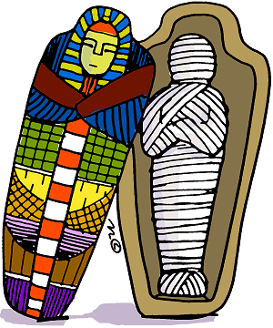
Cover the corpse with natron (salt) for 40 days. | 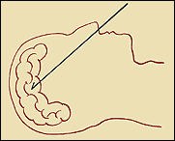
 | 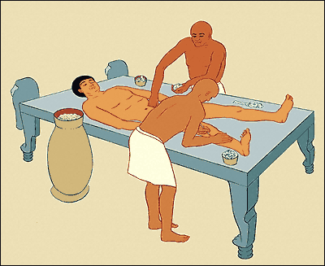
After the 40 days, take off the salt, rub the body in oil and then wrap from head to toe in bandages. | 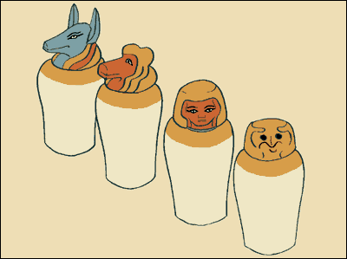
Place in a coffin. | 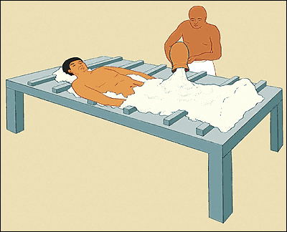

Mummify a tomato!
The first step in mummification is to get rid of the wet and gooey stuff; dry materials are less likely to rot and decay than damp ones. Unfortunately for budding embalmers, tomatoes, like us, contain a huge amount of water. The drier we can get our tomato the less likely it will rot.
Children can test this idea by sealing slices of bread in two separate Ziploc bags - or closed plastic bottles. They’ll also need to place a 1cm layer of dry sand in one container and a similar layer of damp sand in the other. After a few days, observe which conditions are best for mould to grow on the bread - yucky but fascinating! Dispose of carefully.
Watch and learn
Before you start – observe your tomato really carefully. What does it feel like, smell like, what colours can you see, what about the texture of the skin? Keep an un-mummified tomato as a control to provide a comparison.
To dry out our tomato we need to make a small incision in the fruit and scoop out the seeds inside. You can throw these inside bits away. The Egyptians did the same with the internal organs.
The body cavity was then washed with wine as the alcohol was supposed to kill germs. Children can carefully rub their tomato inside and out with a dilute anti-bacterial solution like Milton then dry the excess with kitchen paper.
Now weigh your mummy. This is the pre-mummification weight with water.
Next we need to pack the body with a type of naturally occurring salt called natron. We can’t easily get real natron, but we can make it from a mixture of table salt and bicarbonate of soda; Epsom salts work well too. More able children can explore the different combinations and proportions of chemicals that work best in mummification, but equal quantities of each is a good mix to start with.
Pack your tomato cavity with your natron and then place the tomato in a container so it is completely covered with the salt and bicarbonate of soda mix. Check its progress every few days; you may need to replenish the natron to keep it dry.
The Egyptian embalmers had to wait 40 days to complete their mummy, yours should be ready in a couple of weeks. What does it look like now? How have the colour and texture changed? Weigh your tomato again – the difference is the weight of the water that has now been removed. If you want, now you can make and decorate a sarcophagus for your mummified fruit!

A lot of hot air
Despite this painstaking procedure, it was evaporation, caused by the hot and dry Egyptian air, that helped the mummification process the most. You can investigate this in the classroom using salt water. Ask the children to mix up a saturated solution of salt and water – they should reach the point where no more salt crystals will dissolve into the water. Now use the solution to paint a simple Egyptian symbol, such as an ankh, on a piece of black card; you might need to go over it once or twice to apply enough salt water. Leave it to dry – what happens?
You’ll end up with a shimmering white image on the black card where the water has evaporated and left the salt behind. Where has the water gone? Can the children investigate ways to speed up the evaporation process?

